**Instructions for Authors (first two pages):**

We have created this manuscript template to aid our student authors in the formatting of their work when submitting to *IJSI*.

**Using This Template:**

* The following pages include a manuscript template intended for your use during submission.
* Avoid simply copying and pasting your content into this template.
* Carefully review the guidance and examples provided for each section.
* Do not alter the order, remove, or add any sections. The layout must remain exactly as shown in the template.
* Each section includes helpful instructions and notes on common errors to assist authors.
* For more detailed guidance, refer to our comprehensive online submission guide, which we highly recommend reviewing throughout the process to streamline your submission.
* Your final submission should contain only the section headings and your content (in standard font unless italics are required) describing your research.

**General Formatting Items:**

* Use 1 line spacing throughout the manuscript.
* The text should be in Times New Roman, 12-point font.
* Maintain 1-inch margins on all sides of the page.
* The manuscript should not exceed 10 pages,
* This count begins at the Introduction and ends at the Conclusion section.
* Initial submissions may go 1 to 1.5 pages over the limit, as editorial feedback will help refine the content.
* You may include a maximum of 8 figures and tables combined.
* Keep line numbers visible in your document to assist reviewers and editors.
* Avoid using custom formatting for headings and subheadings; all should be in bold, 12-point font.

**Before Submitting:**

* Make sure all listed authors have approved the submission of this work to IJSI.
* Confirm that all images and tables are original to this study.
* If you intend to use any previously published images or tables, you must obtain “**copyright permission”** and contact us before submitting.
* Ensure you have all necessary study approval documents, if required.
* Please refer to our “**Human and Animal Subjects guidelines”** for detailed information.
* When submitting consent forms, include only the blank versions.
* If completed forms are needed, we will reach out to request them after submission.
* Finally, remove the “**Instructions for Authors**” pages from your manuscript before submitting.

**Using Editorial Manager:**

* The senior or corresponding author (or the parent/guardian) must be the one to create the submission account.
* If a parent/guardian is submitting on behalf of a student, they must have the senior author’s permission to publish.
* All communication from IJSI will be directed to the person who submits the manuscript, but authorship order will be taken from the Word file itself.
* The manuscript must be submitted as a Microsoft Word document.
* If a figure includes multiple parts (e.g., Figure 1a, 1b, 1c), it should be saved and submitted as one combined file.
* Any study approval documents should be uploaded under the category labeled “other.”
* Refer to our **submission checklists** to make sure you’ve included everything required.

**Contacting the Journal:**

* If you have any questions during the submission process, feel free to reach out to us at [**submissions@internationalresearchjournal.com**](mailto:submissions@internationalresearchjournal.com).
* If you’ve already submitted your manuscript, please **include the title** of your work and, if applicable, the **manuscript number** (e.g., **IJSI-22-153**) in all email correspondence with the journal.

**Article Title [***110 characters or less***]**

**First Author1, Second Author2, Third Author1,2**

1 Department (if applicable),Institution/School, City, State, Country (if non-US)

2 Department (if applicable),Institution/School, City, State, Country (if non-US)

3 Department (if applicable),Institution/School, City, State, Country (if non-US)

*Affiliations of “unaffiliated”, “mentor”, or that only give general industry/position (i.e., tech sector) are NOT allowed. Authors may default to the student author’s affiliation if needed.*

[**Authorship Guidelines**](https://www.emerginginvestigators.org/submissions/author-eligibility)**:**

* To indicate equal contribution, place an asterisk (*) next to the names of each author who contributed equally.
* Add the statement: "These authors contributed equally to this work" below the author affiliations.
* Every IJSI submission must include a senior (adult) author, typically the person who oversaw the research project.
* This individual may not have been involved in data collection but is expected to have contributed to the experimental design and manuscript preparation.
* Do not include academic degrees (e.g., Ph.D., M.D.) for any authors on the title page; these will be removed prior to publication.

**ABSTRACT**

The abstract should provide a concise and comprehensive summary of your entire study. It should not exceed **250 words** and must be written as a **single paragraph**, without citations or abbreviations (unless standard).

1. *Background/Introduction (1–2 sentences):*  
   Briefly explain the context and significance of the research.
2. *Objective/Aim (1 sentence):*  
   Clearly state the purpose or hypothesis of the study.
3. *Methods (2–3 sentences):*  
   Summarize the approach, tools, and techniques used (e.g., molecular docking, AlphaFold, machine learning).
4. *Results (2–3 sentences):*  
   Highlight the most important findings, including specific data if available.
5. *Conclusion and Implications (1–2 sentences):*  
   Conclude with the significance of your findings and possible applications.

**INTRODUCTION**

The Introduction should:

* Clearly define the **background** and **scientific context** of the study.
* Present the **problem** being addressed and why it is important.
* Summarize relevant **previous research** and identify **gaps** in the existing knowledge.
* Establish the **rationale** for your study.
* End with a clear statement of the **research objective**, **hypothesis**, or **question**.

Structure:

1. *Background* – Describe the broader scientific area and key concepts.
2. *Literature Review* – Briefly summarize prior studies and findings.
3. *Knowledge Gap* – Identify limitations or unanswered questions in the current literature.
4. *Purpose* – Clearly state what your study aims to achieve.
5. *Significance* – Emphasize the potential impact or novelty of your research.

**MATERIALS AND METHODS**

The Method section should:

* Provide sufficient detail to allow **replication** of the work.
* Be organized logically by **experimental** or **computational** steps.
* Use past tense and passive or active voice consistently.

Structure:

1. *Study Design* – **Summarize** the overall approach or workflow.
2. *Data Sources/Material Selection* – Describe **databases**, software, or materials used.
3. *Structure Prediction/Preparation* – Explain how **biological** or **chemical** structures were obtained or modeled.
4. *Computational/Experimental Procedures* – Detail methods used (e.g., modeling, docking, assays), including settings, **parameters**, and **software** **versions**.
5. *Analysis* – Describe how results were **processed, visualized, or validated**.
6. *Reproducibility* – Indicate number of **replicates**, trials, or validation steps used.

**RESULTS**

The Results section should present your key findings in a logical order, supported by figures, tables, and statistical analysis. Avoid interpretation or discussion here — focus strictly on **what** you found, not **what it means**.

*1. Overview of Findings*

* Begin with a **brief introductory paragraph** summarizing what will be covered.

2. Present Data Logically and Sequentially

* Organize the data by experiment or by **hypothesis** addressed.
* Present the **most important results** first.

*3. Include Descriptive Statistics*

* Report values with **units** and relevant **statistical measures** (mean ± SD, p-values, confidence intervals).
* Specify **number of replicates** (n=...) or sample sizes where applicable.

*4. Reference All Tables and Figures*

* Refer to each figure or table in the text with a brief description.

*5. Report Only What Was Found*

* Do not speculate or explain results here (that belongs in the Discussion).
* Mention any **negative results, unexpected observations, or patterns**.

*6. Avoid Redundancy*

* **Don’t duplicate data** presented in figures/tables in the main text—summarize instead.

**DISCUSSION**

The discussion section should interpret and contextualize your findings in light of existing literature, study objectives, and the broader field. This section should not repeat the results, but rather explain their meaning, significance, limitations, and future implications.

*1. Summary of Key Findings*

* Start by briefly **restating** your most important findings.
* Address whether your results **support or contradict your initial hypothesis** or research question.

*2. Interpretation of Results*

* Discuss what the results mean biologically, chemically, socially, etc.
* Compare your findings with previous studies—do they align or differ? Why?
* Provide **potential mechanisms** or explanations if appropriate.

*3. Strengths of the Study*

* Highlight what makes your study **unique** or **innovative**.
* Point out the rigorous methods, sample size, or novel approach.

*4. Limitations*

* Be transparent about **limitations** in your methodology, data, or scope.
* Mention any **potential biases, sample size constraints, or generalizability issues**.

*5. Implications*

* Describe how your findings could affect **future research**, policy, industry applications, or clinical practice.
* Indicate any **real-world relevance** or **translational potential.**

*6. Future Directions*

* Suggest specific experiments or computational analyses that should be pursued next.
* Address unanswered questions and propose hypotheses for future testing.

**ACKNOWLEDGMENTS (Optional)**

The preferred spelling of the word “acknowledgment” in America is without an “e” after the “g”. Avoid the stilted expression “one of us (R. B. G.) thanks ...”. Instead, try “R. B. G. thanks...”. Put sponsor acknowledgments in the unnumbered footnote on the first page.

**REFERENCES *(APA Format)***

List all sources cited in your manuscript in **APA 7th edition format**. Ensure all in-text citations match this list.

* Smith, J. A., & Johnson, R. B. (2021). *Molecular mechanisms in disease targeting*. *Journal of Biomedical Research*, 14(3), 215–230. https://doi.org/10.1000/jbr.2021.0001
* World Health Organization. (2020). *Cancer fact sheet*. <https://www.who.int/news-room/fact-sheets/detail/cancer>

Use a hanging indent for each reference. Alphabetize the list by the first author's last name.

**FIGURES AND TABLES**

|  |  |  |
| --- | --- | --- |
| **Concentration (µM)** | **Cell Viability (%)** | **p-value vs. Control** |
| **0 (Control)** | 100 ± 2.3 | — |
| **5** | 89.2 ± 3.1 | 0.04 |
| **10** | 73.5 ± 2.8 | 0.001 |
| **20** | 45.7 ± 4.0 | <0.0001 |

**Table 1: Quantification of cell viability in response to varying concentrations of Compound X.** Cell viability was assessed using the MTT assay after 48 hours of treatment. Data represent mean ± SD of three independent experiments. Statistical analysis was performed using one-way ANOVA followed by Tukey’s post hoc test.

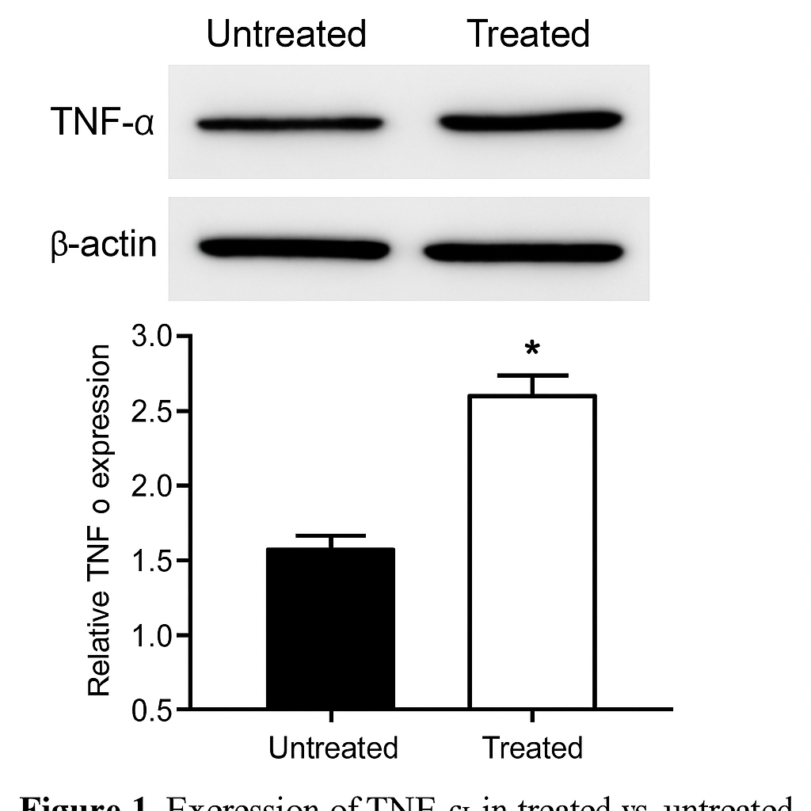

**Figure 1: Expression of TNF-α in treated vs. untreated macrophage cells.** Western blot analysis showing TNF-α expression in RAW264.7 cells after 24 hours of treatment with Compound X (10 µM). β-actin was used as a loading control. Densitometry analysis was performed using ImageJ, and data were normalized to untreated control.